Hangman Game in React.js
with API-fetched words and definitions

NOTE:
This document is work in progress and has many missing parts

Project Description

Design Overview

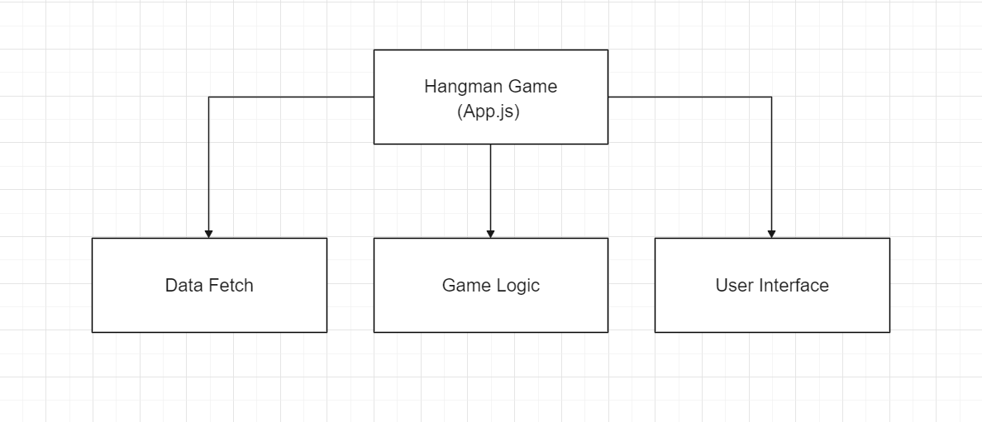
The website, like many programs, consists of 3 key parts:
- Acquire Data to be used in the program
- The logic of what happens to/with the data
- User interface to display the current state or result of the logic applied to the data

As each module/component is designed with one key task in mind, for multiple modules to cooperate we need to have an overarching module that is used for managing and transferring data between it’s submodules.

Top-level overview
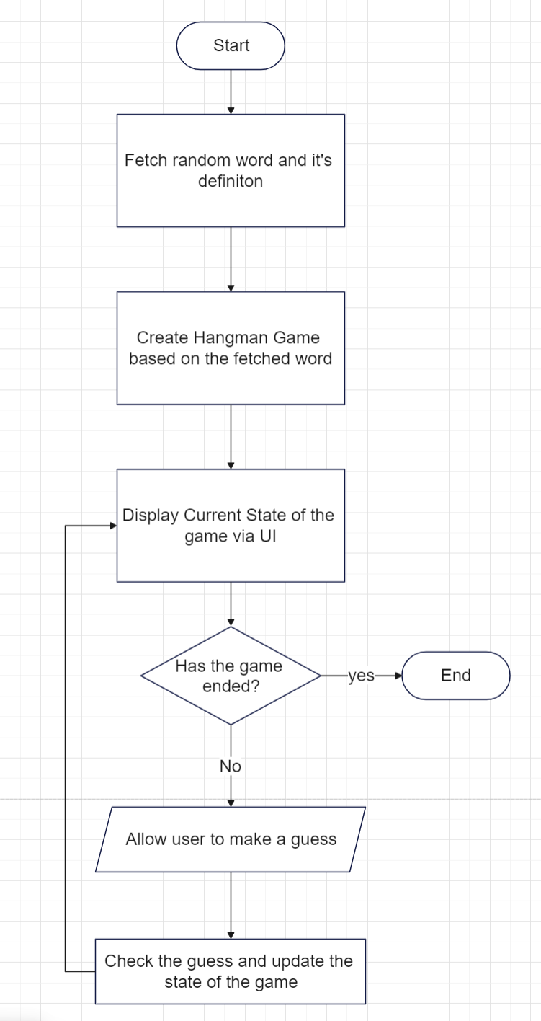
The basic principle of the program is simple, fetch a word, display empty spaces and allow user to make guesses, displaying the correct ones and removing ‘lives’ for the incorrect ones until either the user guesses all letters correctly OR runs out of tries.

Design of the App
When the site loads we first generate a random word which we then pass to the function that returns definitions of the word passed as an argument and store the returned data in a variable.
We than create new instance of the Hangman Game object passing the random word to the constructor which deals with all the game logic and keeps track of game progress.
Then we generate the user interface based on information from the game instance.
When user makes a guess using the interface we pass the value of the guess to the game instance and re-render the interface to reflect the result of the guess.

Design of Data Fetch
‘Data Fetch’ component itself is just way to contain two very closely related for our needs but otherwise stand-alone functions:
- Fetch random word from one API
- Fetch the definitions of the word we just got from another API

For the sake of reusability of the modules in the future they will be self contained and built on Axios to allow modularity.

Random Word Generator
Make an API request and process the JSON response so that the output of the function is just a string with the word we got in the JSON response.

Fetch Definition
Call dictionary API with the word passed as an argument to the function return the received JSON response.

Design of Game Logic
The logic of the game is self contained and is not dependant on any other module or component as the game itself doesn’t render anything which makes it easily reusable and highly versatile.

We create a new game object and pass the word for the game to the constructor after which the game is ready to play.

Depending on the source the rule-set differs. Some play it with the gallows present from the start, while others draw them during the game which results in different number of chances to guess:
With gallows: 6th incorrect guess loses the game
Without the gallows: 10th/11th, depending on the way someone chooses to draw the gallows.
Without any particular reason other than being somewhere in the middle the game defaults to 10 but allows for changing that to any integer as long as no guesses have been made yet.
The game is played by calling object’s function and passing the guessed character as an argument. Calling the function with a letter that has already been guessed is ignored.

Design of User Interface
The interface can be split into two categories: website interface, and game interface. By splitting the two the game itself can be imported in other places when desired promoting modularity, equally, working on the design of the website styling doesn’t risk unknowingly altering the design of game interface.

Website Interface
Website interface can be divided into two categories based on whether the interface deals with general website functionality, and carries between different subpages or if it is specific to the content displayed.

General
For this project the general interface is kept to minimum and only allows for switching between light and dark mode but it’s functionality may be expanded when more modules get developed in the future.

Specific
Extra component extends the functionality of the Hangman Game component by displaying definitions of the word player was trying to find when the round ends, hopefully allowing them to learn something new.

Game Interface
There are 4 main components to the conventional Hangman Game interface. Three of them are for displaying information to the user:
- Empty/Correct characters user tries to guess
- Drawing of the hangman
- List of characters that have been guessed and are out of the game
While the last element is used by the player to make guesses.

As the game logic is completely decoupled by design, it cannot interact with user interface components and therefore requires a container component that will interact with the game object and configures elements of user interface based on the information returned by the game object.
In this project the main ‘App.js’ component will be taking on this duty.
For the game to have the required interface elements we are using 3 components:

Word Component
Simplest of the 3, simply displays the characters passed to it to display the missing and present letters.

Hangman Component
Most visually complicated component: it receives the number of incorrect guesses and progressively constructs the gallows and the hangman.

On-Screen-Keyboard Component
Double purpose component which allows for both user to select letters AND customizing the way each letter is displayed allowing for tracking the already guessed letters by removing them or styling them differently.

Environment

Framework
For this project we’re using React.js with the project created using ‘react-create-app’.

External Libraries Used
To allow for both easier and better development two free libraries are being used, those are:

Material UI

Home Page
MUI: The React component library you always wanted

Description
Ready to use components for quick and easy UI development

Axios

Home Page
Axios: Promise based HTTP client for the browser and node.js

Description
Axios provides a simple to use library in a small package with a very extensible interface.

Setting Up
This section is split into 2 sections: installation and configuration.
This document assumes it’s not Your first React.js project and therefore will skip any info on setting up node.js and React.

Installation
To get started You simply need to clone(download) the git repository of this project, then get to the project’s directory in Your terminal of choice after which You will need to use
‘npm install’
This will download and install all the required modules from the internet.

Environment
It is important to know what ‘environmental variables’ are and why they are important but those who are aware of the details can skip over the next ‘Why” section straight into the “How” section. Whichever group You’re in, I strongly advise to make sure to read the “notes” section.

Why
Before You start developing it’s vital You set up environmental variables for this project.
- When we store values in the environmental variable, environment refers to the container that’s dealing with actually running the code. Different environments will have different characteristics as, for example running Your app on a phone and a computer will have different characteristics that software has to account for, for e.g. screen size, computing power or ways user can interact with the software.
- When app is being developed, it may also be run in different environments on the same machine concurrently depending on the needs of the developers.
- To communicate information about the environment the program is being run in, to the program, we use environmental variables with, hopefully, standardized naming so that when the code runs, even when it doesn’t know where it is, by asking standard questions like ‘screen size’ we can adapt the program to run in the way designed for that specific ‘environment’.

- We also use environment variables to store secrets that are specific to that specific environment(machine/device/system).
- It is especially important when working on publicly-available code as we don’t want to expose the password to our databases, keys to APIs we paid for and anything else that we need to use for the program but don’t want unauthorized use of.
- By setting up environmental variable and then using that variable in the code we allow for everyone to run the same code yet still don’t share secrets with each-other by using our private keys so that nobody can abuse someone else’s key and blame it on them.
- As the code doesn’t change, only the value of the variable it is important for everyone to name it the same way so that the code doesn’t have to account for that.

How

The‘.env.local’ file
In Your ‘.env.local’ file you need to define the API key the code will be using to make request to the API provided by ‘API NINJAS’.
The File should be located in the root directory of the project, if it’s not there You need to create one.
Your ‘.env.local’ file should be located in the same directory as ‘package.json’

API-Key
You can get a free API key that works for all the APIs they offer by registering on their website Random Word API - API Ninjas (api-ninjas.com).
Once You have Your API key, open your ‘.env.local’ file and create a line containing:
REACT_APP_API_NINJAS_API_KEY = ‘YOURAPIKEY’
Remember to enclose the key in single quotes.

Notes
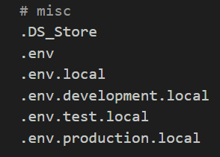
- Make sure your ‘.gitignore’ has a line for ‘.env.local’ to ensure your key doesn’t get pushed
You can place it on any line for it to work but it’s the best to put it the same category as other ‘.env’ files already listed there, the ‘misc’ category like so
- Due to the design choices for the React.js software, environmental variables have to start with ‘REACT_APP_’ or they won’t work
- The values from ‘.env’ files are loaded when the development server is started and don’t update from then-on. This means that if You create, remove or edit environmental variables when the server is running, they won’t update until you shut the server down and use ‘npm start’ again.

Components

Component Implementation
To allow for easy cooperation and to make splitting the work into smaller, more manageable chunks we can user unit testing.

Unit Testing
By describing in a test what we want to happen as result of calling a function we can then ensure desired functionality without having to worry about the details of how to achieve it right now. This allows for letting someone else do the work and knowing the function will work in the way intended in the design.

For example, if we create a test “check if function “AddTwoNumbers” returns correct value we can specify in test that we want to call the “AddTwoNumbers” function with two number as arguments, for example 3 and 2, and we expect it to return 5.
If the function behaves in the way we expect it to, that is, the way we specified in the test when creating it, the test will pass. Otherwise it fails.

Existing and new functions can be tested using
‘npm test’
which will run and provide a list of tests that passed and those that failed to see what things need to be worked on.
The tests are designed in such a way that You only need to alter the code of the function, nothing else needs to be updated.

Data Fetch

RandomWordGenerator.js
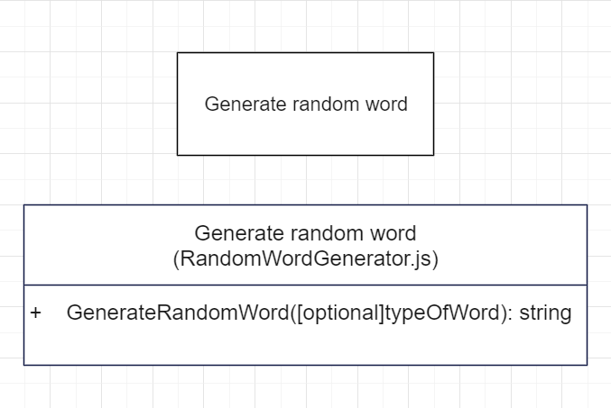

API docs
Random Word API - API Ninjas (api-ninjas.com)

Description
The Random Word API generates unique and interesting words for songs, games and education applications.
(English only)

Implementation
Function should take an optional argument as to allow for selecting the category of the generated word.
API key should be stored in ‘.end’ file that is discussed on the ‘Environment’ section and accessed by using ‘process.env.REACT_APP_API_NINJAS_API_KEY’
Functionality should be achieved by using Axios to make the API request.
Possible values are: noun, verb, adjective, adverb.
Function should return the generated word as a string.

FetchDefinition.js
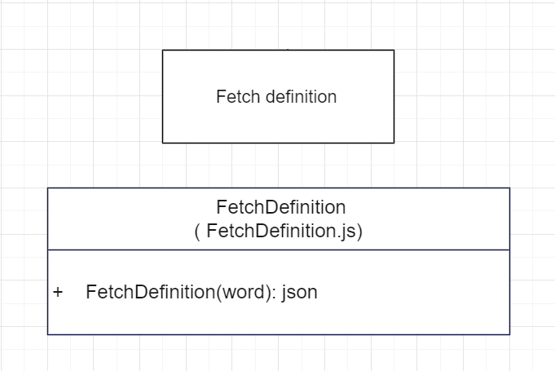

API docs
Free Dictionary API

Description
Free to use dictionary API for developers

Implementation
Function should require one one argument that is a string.
Functionality should be achieved by using Axios to make the API request.
Function should return the JSON response received.

Table of Contents
Project Description 2
Design Overview 3
Top-level overview 4
Design of the App 5
Design of Data Fetch 6
Random Word Generator 6
Fetch Definition 6
Design of Game Logic 7
Design of User Interface 8
Website Interface 8
General 8
Specific 8
Game Interface 8
Word Component 9
Hangman Component 9
On-Screen-Keyboard Component 9
Environment 10
Framework 10
External Libraries Used 10
Material UI 10
Home Page 10
Description 10
Axios 10
Home Page 10
Description 10
Setting Up 11
Installation 11
Environment 11
Why 11
How 12
The‘.env.’ file 12
API-Key 12
Notes 13
Components 14
Component Implementation 15
Unit Testing 15
Data Fetch 16
RandomWordGenerator.js 16
API docs 16
Description 16
Implementation 16
FetchDefinition.js 17
API docs 17
Description 17
Implementation 17

elemat28

